Exercise-5

Enhanced Decorator Pattern: Notification System with Receiver Details

**1. Introduction**

This document outlines the implementation of an enhanced Decorator Pattern for a flexible notification system. The system allows sending notifications through multiple channels (Email, SMS, Slack) and includes receiver details for more realistic notification handling.

**2. Problem Statement**

Develop a notification system that:

* Supports multiple notification channels (Email, SMS, Slack)
* Allows dynamic selection of notification channels
* Includes receiver details (name, email, phone number)
* Validates the availability of contact information before sending notifications
* Provides a user-friendly interface for sending notifications

**3. Solution Overview**

The solution uses the Decorator Pattern to create a flexible notification system. Key components include:

* A base notifier interface and implementation
* Decorator classes for each notification channel
* A Receiver class to encapsulate recipient details
* A test class for user interaction and demonstration

4. Implementation

Link: [click here for the code](https://github.com/Akashmondal55/Akash_5016855/tree/main/Week-1/Design%20patern%20and%20princple/Exercise-5)

5. **Explanation of the Enhanced Decorator Pattern**

The enhanced Decorator Pattern implementation in this notification system demonstrates several key concepts:

1. **Core Functionality**: The BaseNotifier provides the basic notification functionality.
2. **Decorators**: EmailDecorator, SMSDecorator, and SlackDecorator add specific channel notifications.
3. **Dynamic Composition**: The client code can dynamically compose different notification channels based on user input.
4. **Receiver Information**: The Receiver class encapsulates recipient details, allowing for more realistic notification handling.
5. **Validation**: Each decorator checks for the availability of necessary contact information before sending a notification.
6. **Open/Closed Principle**: New notification channels can be added by creating new decorators without modifying existing code.
7. **Single Responsibility**: Each class has a single, well-defined responsibility, enhancing maintainability.

**8. Output**

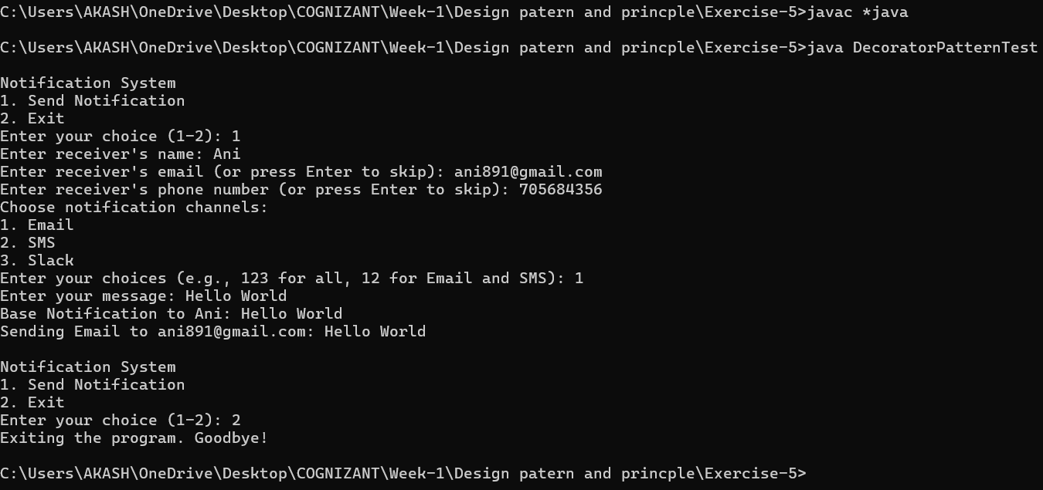

**9. Conclusion**

This enhanced implementation of the Decorator Pattern showcases a flexible and extensible notification system. It demonstrates how the pattern can be adapted to handle complex, real-world scenarios while maintaining its core benefits of dynamic composition and extensibility. The addition of receiver details and contact information validation makes the system more practical and user-friendly.

The implementation successfully meets the requirements of supporting multiple notification channels, allowing dynamic selection, including receiver details, and providing a user-friendly interface. It serves as an excellent example of applying design patterns to solve real-world problems in software development.